TA
Average number of Core Threat Assessment Team members: 7.12
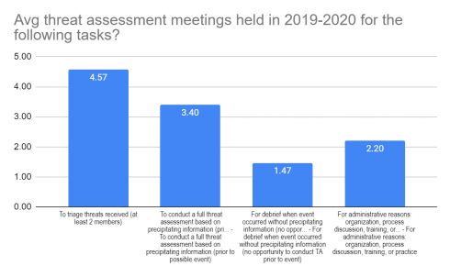
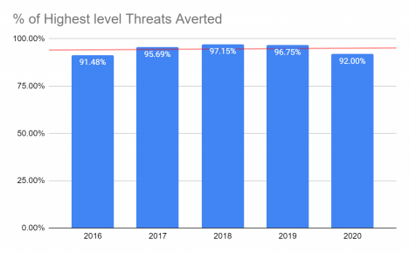
 | 2014 | 2015 | 2016 | 2017 | 2018 | 2019 | 2020
Total of all threat assessments completed in the state for each year | 3569 | 5522 | 6029 | 8309 | 14869 | 16573 | 15524
Threats of harm to only others for each year |  | 2891 | 3123 | 3658 | 5790 | 5893 | 5860
Threats of harm to only self for each year |  | 2419 | 2556 | 4201 | 8294 | 9868 | 9037
Threat to self AND others |  | 212 | 350 | 450 | 785 | 812 | 1209
# of Highest level of threat for each year |  |  | 657 | 928 | 1472 | 1169 | 1237
Highest level  averted |  |  | 601 | 888 | 1430 | 1131 | 1138

